1. What is AI and ML?

Artificial intelligence is [intelligence](https://en.wikipedia.org/wiki/Intelligence) demonstrated by [machines](https://en.wikipedia.org/wiki/Machine), in contrast to the natural intelligence (NI) displayed by humans and other animals. In [computer science](https://en.wikipedia.org/wiki/Computer_science) AI research is defined as the study of "[intelligent agents](https://en.wikipedia.org/wiki/Intelligent_agent)": any device that perceives its environment and takes actions that maximize its chance of successfully achieving its goals. Colloquially, the term "artificial intelligence" is applied when a machine mimics "cognitive" functions that humans associate with other [human minds](https://en.wikipedia.org/wiki/Human_mind), such as "learning" and "problem solving".

Machine learning is an application of artificial intelligence (AI) that provides systems the ability to automatically learn and improve from experience without being explicitly programmed. **Machine learning focuses on the development of computer programs** that can access data and use it learn for themselves.

1. Difference between AI and ML?

AI and ML are both disciplines of the[Data Science platform](https://bigclasses.com/data-science-online-training.html?utm_campaign=Vamsi&utm_source=Quora). They both are equally important in this field, but they are quite different from each other.

Sometimes, they can be stated as the same discipline, but they do have their own unique characteristics. These two concepts arise when there is a discussion on Big Data, Data Analysis, and more.

But Artificial Intelligence (A.I) is a broader concept of machines which is able to carry out various tasks in smarter ways. While Machine Learning is a new application of the AI. This is based on the idea to give data access to the machines so that they can learn from themselves.



AI has been known for a very long time. There was a Greek myth that described mechanical men mimicking the human activities. The early computers were known as the logical machines which have a good memory and could solve arithmetic problems. Therefore, engineers all around the world were reluctant to create and design the best mechanical brains for making human tasks easier.

We have evolved for centuries. Our thinking process has improved and has been improvising constantly. And therefore, out work and work methods have taken to a new level, and hence the requirements in the AI have also evolved. We now want an AI to analyze the huge volumes of data, calculate complex data, understand the human activities and mimic their behavior, and later help them with their needs.

The AI is the devices designed specifically to act intelligently with the application of two fundamental groups namely – applied and general. The Applied AI is the most common system which was designed to trade stocks and shares efficiently. The General AI is the system which is designed to handle any tasks, but is less common compared to the Applies AI. This area has advanced and has led to the development of the Machine Learning. Yes! Machine Learning comes from the Artificial Learning – the General AI.

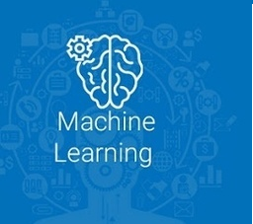

[Machine Learning](https://bigclasses.com/data-science-online-training.html?utm_campaign=Vamsi&utm_source=Quora) was a breakthrough discovery while the AI was evolving. The reason for ML was due to two reasons. The first was when the vehicle was driven by the AI. That is when the AI was designed to learn things by themselves. The second, there was a need for an intelligence that could handle the enormous digital information that was being generated, stored, and was made available for the analysis.

Engineers hence understood the importance of this, and they started teaching the computers and machines to understand the human activities and behavior. They then could be plugged on the internet and they could gain all the information.

[Machine Learning](https://bigclasses.com/data-science-online-training.html?utm_campaign=Vamsi&utm_source=Quora) was a breakthrough discovery while the AI was evolving. The reason for ML was due to two reasons. The first was when the vehicle was driven by the AI. That is when the AI was designed to learn things by themselves. The second, there was a need for an intelligence that could handle the enormous digital information that was being generated, stored, and was made available for the analysis.

Engineers hence understood the importance of this, and they started teaching the computers and machines to understand the human activities and behavior. They then could be plugged on the internet and they could gain all the information.

AI is a computer program that does something smart. It can be a pile of if-then statements or a complex statistical model. Usually, when a computer program designed by AI researchers actually succeeds at something -- like winning at chess -- many people say it's "not really intelligent", because the algorithms internals are well understood. So you could say that true AI is whatever

computers can't do yet.  
  
Machine learning, as others here have said, is a subset of AI. That is, all machine learning counts as AI, but not all AI counts as machine learning. For example, symbolic logic (rules engines, expert systems and knowledge graphs) as well as evolutionary algorithms and Baysian statistics could all be described as AI, and none of them are machine learning.   
  
The "learning" part of machine learning means that ML algorithms attempt to optimize along a certain dimension; i.e. they usually try to minimize error or maximize the likelihood of their predictions being true. How does one minimize error? Well, one way is to build a framework that multiplies inputs in order to make guesses as to the inputs' nature. Different outputs/guesses are the product of the inputs and the algorithm. Usually, the initial guesses are quite wrong, and if you are lucky enough to have ground-truth labels pertaining to the input, you can measure how wrong your guesses are by contrasting them with the truth, and then use that error to modify your algorithm. That's what neural networks do. They keep on measuring the error and modifying their parameters until they can't achieve any less error.   
  
They are, in short, an optimization algorithm. If you tune them right, they minimize their error by guessing and guessing and guessing again.

1. What is future of AI and ML?

* Deeper personalization. In the future, users will receive more precise recommendations and ads will become both more effective and less annoying.
* Neural networks running on our mobile devices. Mobile device may have the ability to conduct machine learning tasks locally, opening up a wide range of opportunities for object recognition, speech, face detection, and other innovations for mobile platforms.
* Mobile experience automation. There are a lot of apps that automate the work of different connected apps (like [IFTTT](https://ifttt.com/)) or the device’s OS the whole (like [Tasker](https://play.google.com/store/apps/details?hl=en&id=net.dinglisch.android.taskerm)). However, such apps may be clumsy or difficult to use. What if a device could be automated by machine learning algorithms? And what if this automation could be extended to the Internet of Things? Google already [patented](http://www.google.com/patents/US8429103) a similar idea back in 2012, so it’s possible we’ll see an implementation of this sort of technology sooner or later.
* Real-time speech translation. In late 2014 Skype launched [Skype Translator](https://www.skype.com/en/features/skype-translator/). It’s been improving the service since then, and currently provides real-time audio translation among seven languages. If this technology continues to develop, it could significantly improve the quality of international communication or even eradicate language barriers.
* Health and fitness. Fitness tracking wearables and apps are pretty popular right now. People gladly use wearables and connected apps to track their sport activities and everyday life. Machine learning has the potential to take this a step further, however, by providing more detailed feedback and tips about a user’s activity and condition, making fitness trackers more effective.
* Prolonging a mobile device’s battery life. This may sound a lot less epic than other possibilities of machine learning, but preserving battery life is one of the most frustrating concerns for mobile app users. Along with the automation of system resource allocation for apps, machine learning could also reduce the amount of unnecessary battery consumption by apps.

According to a recent report by Accenture, AI has the potential to add close to $957 Billion to the Indian economy by changing the nature of work, to create better outcomes for business and society. The report called ‘Rewire for Growth’ predicts that AI intervention could increase India’s annual growth rate of gross value added (GVA) by 1.3 % points, thus lifting the country’s income by 15% in 2035.

Machine learning is one of those things where the only limit to how far it can go, is our own imaginations. Several things that were thought to be impossible by the older generation, are now a commonplace in our lives. And in the due course of time, we would also experience things that we could only dream of. And personally, I believe machine learning would be one of the catalysts to changing our future as we know it.

We’re so reliant on machine learning now, that life without it would be unimaginable.

For example, when you’re booking a taxi, you’re shown how much the trip would cost. Or when you’re on the trip, you’re shown the path the taxi would take to reach your destination. All of that, is machine learning.

While booking a ride on Uber, you’re always told the amount of time the trip would take and how much it would cost. Machine learning helps obtain this information.

Or when you’ve posted a picture on Facebook. And immediately, you’re given suggestions on whom to tag in the photo.

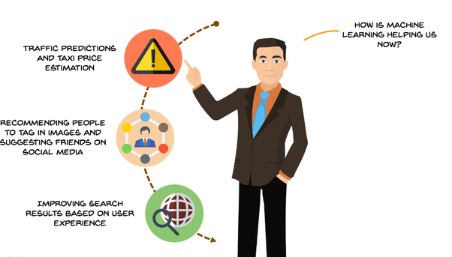

Let’s talk about the future now.

Like I mentioned before, the possibilities are endless. But here’s some I’m personally excited for.

Now we could have endless debates on whether AI would could end up with a terminator-esque situation. But a life made easier with robots taking care of our daily needs sounds pretty awesome doesn’t it?

After a long day of work, there’s nothing like a little R &R. What if you could start relaxing in your car ride home? If you had nothing to worry about the annoying traffic? Self-driving cars would help, thanks to machine learning!

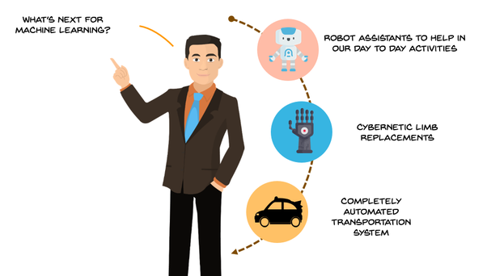

More importantly, people experienced with machine learning are in high demand now!

Don’t believe me?

This graph from [Job Search | Indeed](http://indeed.com/) may change your mind.

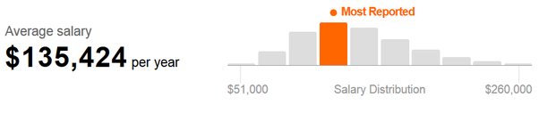

1. What does AI do ?

Artificial Intelligence is constantly pushing the boundaries of what machines are capable of. But could machines ever become better than us? The answer is of course ‘yes’, at least in many things where our intellect used to be the unchallenged champion of creativity and intelligence. Here are 5 tough intellectual areas where AI is already performing better than humans.

**Search the web quicker**  
RankBrain is a machine learning AI that handles the toughest web queries in Google’s search engine. It understands the meaning of words and phrases, and can therefore guess what should be to the top ranking pages in never-seen-before searches. And it is better than its biological creators. [When tested](http://searchengineland.com/meet-rankbrain-google-search-results-234386), humans could guess 70% of the time, while RankBrain’s success rate was 80%. It has not replaced Google’s brute force Hummingbird Search algorithm yet, but works synergistically with it; a sign of things to come as AI is embedded into existing information systems in order to enhance their performance.

**Work in deadly environments**  
Robots can survive where no human can, in places like deep space, the oceanic benthos, or inside a radioactive reactor. The trouble has been that they could not perform at the dexterity and intelligence level of humans. As robotics pioneer Hans Moravec has famously noted, although high-level reasoning is relatively cheap to implement when it comes to low-level sensorimotor skills AI needs enormous computational resources. In other words, human babies can do more complex things with their bodies than the most sophisticated robots. But not any more: [a UC Berkley team](http://www.nytimes.com/2015/05/22/science/robots-that-can-match-human-dexterity.html?_r=1) used deep learning to teach robots fine motor skills, such as screw caps on bottles, or use the back of a hammer to remove a nail from wood. The technique simulates eye-hand coordination in humans and the research results show that robots can now match human dexterity and speed.

**Translate in many languages**  
In the “Hitchhiker’s Guide to the Galaxy“ the babelfish was a fictitious alien fish that performed instant translation once inserted into one’s ear. AI is catching up quickly with science fiction, as so-called “machine translation” is finally coming of age. The [Google Translate app](http://observer.com/2015/07/google-ai-now-lets-users-instantly-translate-text-in-27-languages-with-phone-cameras/) can instantly translate text in 27 languages. And Skype is using neural network technology that mimics the human brain in order to understand human speech and instantly translate from English to Spanish. At Microsoft, who own Skype, are beta testing the method with a view to expand it in any language, and thus facilitate face-to-face communication between humans with no knowledge of each other’s language.

**Get a PhD quickly**  
Critics of AI nauseatingly argue that machines could never be creative, or curious, or discover anything of significance - because they lack consciousness. Nevertheless, [a team at Tufts](http://now.tufts.edu/news-releases/planarian-regeneration-model-discovered-artificial-intelligence)have proved naysayers wrong. Intelligence does not need consciousness to discover new knowledge. By combining genetic algorithms with genetic pathway simulation the researchers created a system that was able to make the first scientific theory to be discovered by an AI: of how flatworms (or the species “planaria” to the initiated) regenerate body parts. The AI-generated theory will have a significant impact in human regenerative medicine.

**Deliver a correct medical diagnosis**  
Ever since that day in 2011 when it beat the human champions of Jeopardy!, IBM Watson has been growing its capabilities with leaps and bounds. One of its focus areas has been oncology and the diagnosis of cancers. For human physicians the challenge of making correct diagnosis is huge. It is estimated that in order to be at top of medical knowledge human doctors must spend 160 hours per week reading new research papers. IBM Watson’s AI does that at a fraction of the time. On top of

this it has the ability to search through millions of patient records, learn from previous diagnoses, and improve the reasoning links between symptoms and diagnosis. The result? [IBM Watson’s accuracy rate](http://republic-of-innovation.ch/ibms-watson-could-diagnose-cancer-better-than-doctors/) for lung cancer is 90%, compared to a mere 50% of human physicians.

And yet, although AI has conquered many of the high castles of human intellect it is still limited because it lacks our ability for general reasoning. AI systems can do any the above 5 things better than any human, but there is not a single AI that can do all 5 things together, or more. “General intelligence” remains the Holy Grail for AI research. Once achieved, we will have arrived at the beginning of a truly intelligent mechanical mind. Nevertheless, [DeepMind’s seminal paper](http://www.nature.com/nature/journal/v518/n7540/full/nature14236.html) last year in Nature demonstrated how AI could develop general intelligence; in the example presented in the paper a deep learning algorithm was able to play many different Atari games by reasoning from first principles. So watch that space in the next two to five years, as researchers build on top of DeepMind’s DQN (“Deep Q-networks”) algorithm, and AI enters a new phase of accelerated evolution.

1. How does machine learning work ?

Machine learning systems are made up of three major parts, which are:

* **Model:** the system that makes predictions or identifications.
* **Parameters:** the signals or factors used by the model to form its decisions.
* **Learner:** the system that adjusts the parameters — and in turn the model — by looking at differences in predictions versus actual outcome.

Now let me translate that into a possible real world problem, based on something that was discussed yesterday by [Greg Corrado](http://research.google.com/pubs/GregCorrado.html), a senior research scientist with Google and cofounder of the company’s deep learning team.

Imagine that you’re a teacher. You want to identify the optimal amount of time students should study to get the best grade on a test. You turn to machine learning for a solution. Yes, this is overkill for this particular problem. But this is a very simplified illustration!

## Making The Model

Everything starts with the model, a prediction that the machine learning system will use. The model initially has to be given to the system by a human being, at least with this particular example. In our case, the teacher will tell the machine learning model to assume that studying for five hours will lead to a perfect test score.

The model itself depends on the parameters used to make its calculations. In this example, the parameters are the hours spent studying and the test scores received. Imagine that the parameters are something like this:

* 0 hours = 50% score
* 1 hour = 60% score
* 2 hours = 70% score
* 3 hours = 80% score
* 4 hours = 90% score
* 5 hours = 100% score

The machine learning system will actually use a mathematical equation to express all this above, to effectively form a trend line of what’s expected. Here’s an example of that from yesterday’s talk:

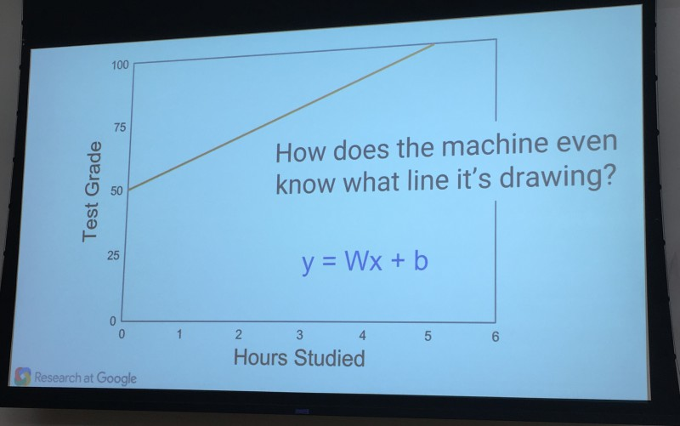

## Providing Initial Input

Now that the model is set, real life information is entered. Our teacher, for example, might input four test scores from different students, along with the hours they each studied.

As it turns out, the scores don’t match the model, in this example. Some are above or below the predicted trend line:

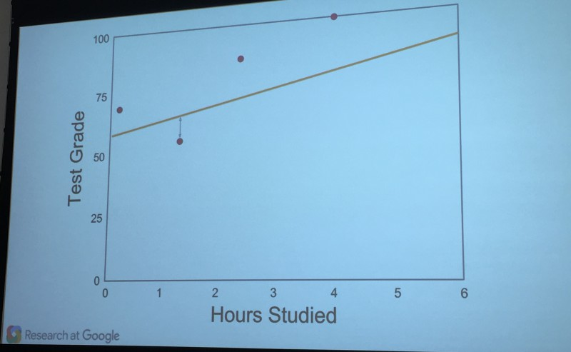

Now it’s time for that learning part of machine learning!

## The Learner Learns

That set of scores that were entered? Data like this given to a machine learning system is often called a “training set” or “training data” because it’s used by the learner in the machine learning system to train itself to create a better model.

The learner looks at the scores and see how far off they were from the model. It then uses more math to adjust the initial assumptions. For example, the list from above might effectively be altered like this:

* 0 hours = 45% score
* 1 hour = 55% score
* 2 hours = 65% score
* 3 hours = 75% score
* 4 hours = 85% score
* 5 hours = 95% score
* 6 hours = 100% score

The new prediction is reworked so that more study time is projected to earn that prefect score.

This is just an example of the process, one that’s completely made up. The most important takeaway is simply to understand that the learner makes very small adjustments to the parameters, to refine the model. I’ll come back to this in a moment.

## Rinse & Repeat

Now the system is run again, this time with a new set of scores. Those real scores are compared against the revised model by the learner. If successful, the scores will be closer to the prediction:

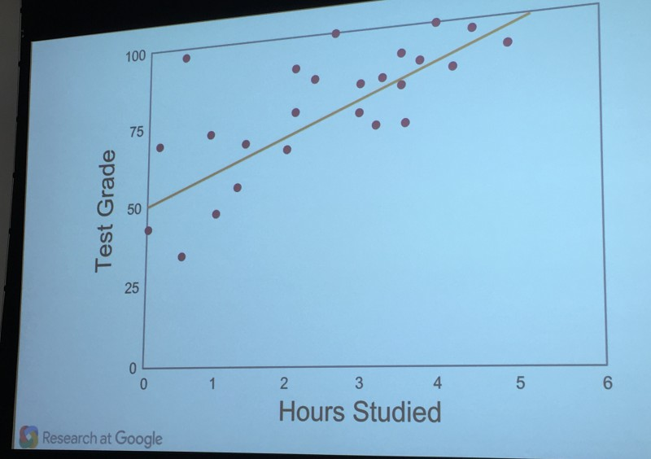

These won’t be perfect, however. So, the learner will once again adjust the parameters, to reshape the model. Another set of test data will be inputted. A comparison will happen again, and the learner will again adjust the model.

The cycle will keep repeating until there’s a high degree of confidence in the ultimate model, that it really is predicting the outcome of scores based on hours of study.

## Gradient Descent: How Machine Learning Keeps From Falling Down

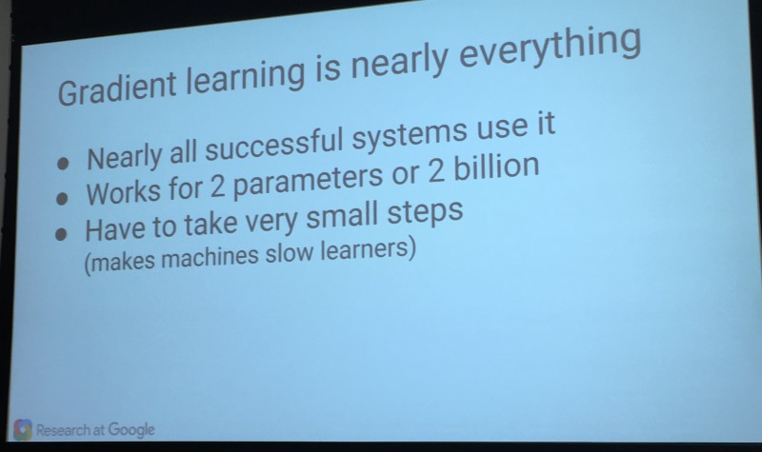

Google’s Corrado stressed that a big part of most machine learning is a concept known as “gradient descent” or “gradient learning.” It means that the system makes those little adjustments over and over, until it gets things right.

Corrado likened it to climbing down a steep mountain. You don’t want to jump or run, because that’s dangerous. You’ll more likely make a mistake and fall. Instead, you inch your way down, carefully, a little at a time.

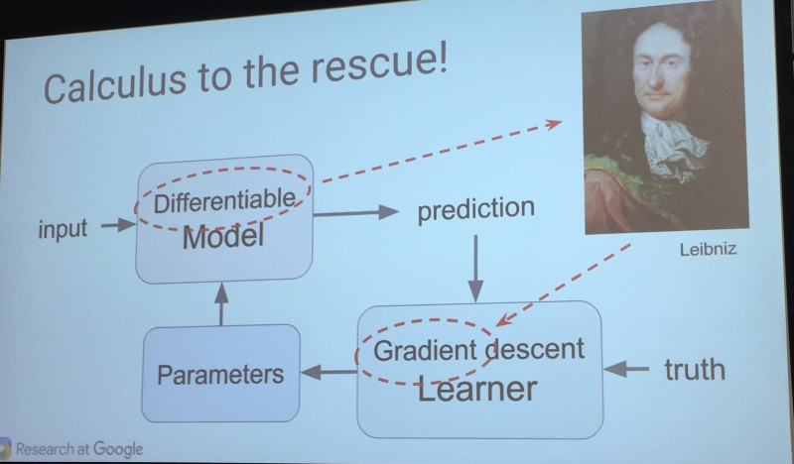

Remember that “the math is easy” line I mentioned above? Apparently for those who know calculus and mathematics, it really is easy, the equations involved.

The real challenge, instead, has been the computing horsepower. It takes a long time for machines to learn, to go through all these steps. But as our computers have gotten faster and bigger, machine learning that seemed impossible years ago is now becoming almost commonplace.

## Getting Fancy: Identifying Cats

The example above is very simplistic. As said, it’s overkill for a teacher to use a machine learning system to predict test scores. But the same basic system is used to do very complex things, such as identifying pictures of cats.

Computers can’t see as humans can. So how can they identify objects, in the way that Google Photos picks out many objects in my photos:

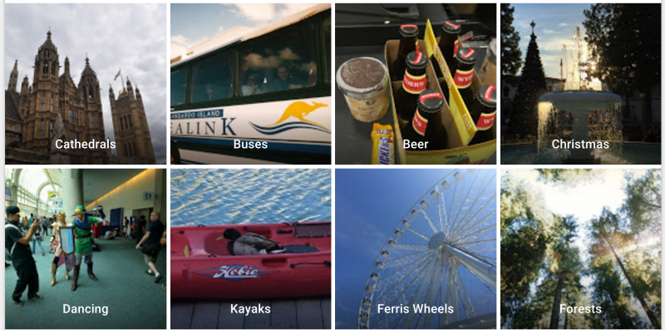

Machine learning to the rescue! The same principle applies. You build a model of likely factors that might help identify what’s a cat in images, colors, shapes and so on. Then you feed in a training set of known pictures of cats and see how well the model works.

The learner then makes adjustments, and the training cycle continues. But cats or any object identification is complicated. There are many parameters used as part of forming the model, and you even have parameters within parameters all designed to translate pictures into patterns that the system can match to objects.

For example, here’s how the system might ultimately view a cat on a carpet:

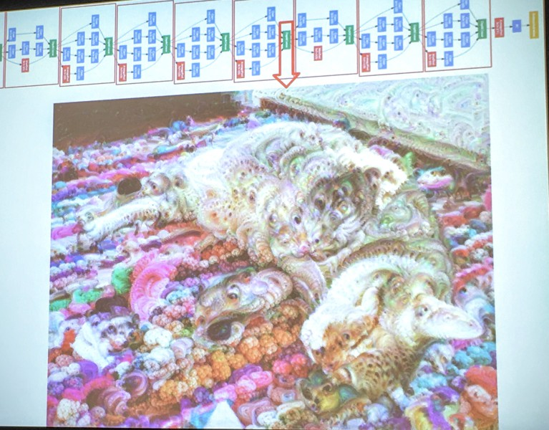

That almost painting-like image has become known as a deep dream, based on the [DeepDream code](http://googleresearch.blogspot.com/2015/07/deepdream-code-example-for-visualizing.html) that Google released, which in turn came out of information it [shared](http://googleresearch.blogspot.com/2015/06/inceptionism-going-deeper-into-neural.html) on how its machine learning systems were building patterns to recognize objects.

The image is really an illustration of the type of patterns that the computer is looking for, when it identifies a cat, rather than being part of the actual learning process. But if the machine could really see, it’s a hint toward how it would actually do so.

By the way, a twist with image recognition from our initial example is that the model itself is initially created by machines, rather than humans. They try to figure out for themselves what an object is making initial groupings of colors, shapes and other features, then use the training data to refine that.

## Identifying Events

For a further twist on how complicated all this can be, consider if you want to identify not just objects but events. Google explained that you have to help add in some common sense rules, some human guidance that allows the machine learning process to understand how various objects might add up to an event.

For example, consider this:

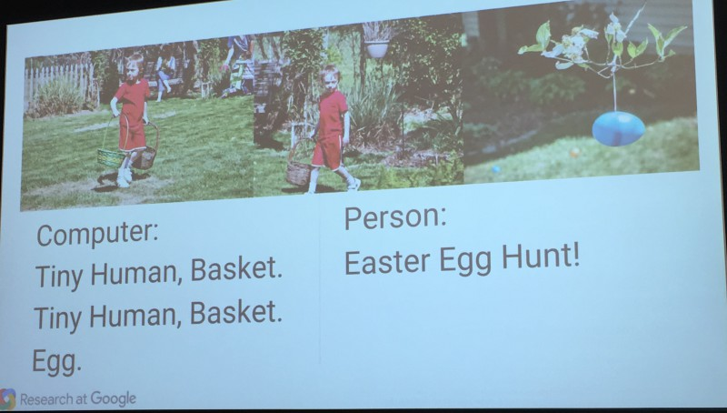

As illustrated, a machine learning system sees a tiny human, a basket and an egg. But a human being sees all these and recognizes this as an Easter egg hunt.

1. Machine learning algorithms – List all the algorithms with examples.

**Classification and Prediction / Regression**

**Classification**

Assigning a class / category to each of the observations in a dataset is called classification. It is done a posteriori, once the data is recovered.

Example: classifying consumers reasons of visit in store in order to send them a personalized campaign.

**Prediction**

A prediction is made on a new observation. When it comes to a numerical variable (continuous) we speak of regression.

Example: predicting a heart attack based on data from an electro cardiogram.

2. **Supervised and unsupervised learning**

***Supervised***

You already have tags on historical data and want to classify new data according to these tags. The number of classes is known.

Example: in botany you made measurements (length of the stem, petals, …) on 100 plants of 3 different species. Each of the measurements is labeled with the species of the plant. You want to build a model that will automatically tell which species a new plant belongs to thanks to the same measurements.

***Unsupervised***

On the contrary, in unsupervised learning, you have no labels, no predefined classes. You want to identify common patterns in order to form homogeneous groups based on your observations.

Examples: You want to classify your customers based on their browsing history on your website but you have not formed groups and are in an exploratory approach to see what would be the common points between them. In this case a clustering algorithm is adapted.

Some neural network algorithms will be able to differentiate between human and animal images without prior labeling.

II. **Machine Learning Algorithms**

We will describe 8 algorithms used in Machine Learning. The objective here is not to go into the details of the models but rather to give the reader elements of understanding on each of them.

***1. “The Decision Tree”***

A decision tree is used to classify future observations given a body of already labeled observations. This is the case of our botanical example where we already have 100 sightings classified in species A, B and C.

The tree begins with a root (where we still have all our observations) then comes a series of branches whose intersections are called nodes and ends are called leaves, each corresponding to one of the classes to predict. The depth of the tree is refers to the maximum number of nodes before reaching a leaf. Each node of the tree represents a rule (example: length of the petal greater than 2.5 cm). To browse the tree is to check a series of rules. The tree is constructed in such a way that each node corresponds to the rule that best divides the set of initial observations (variable and threshold).

Example:

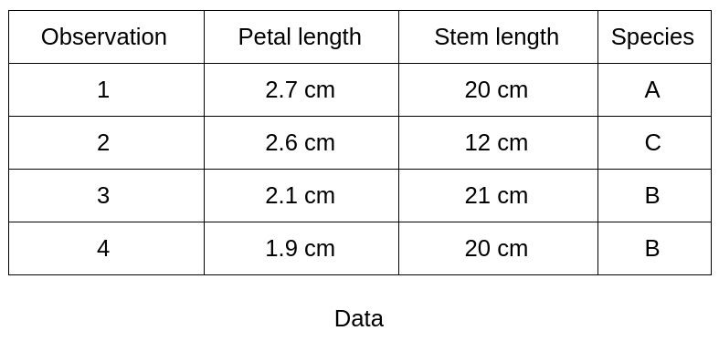

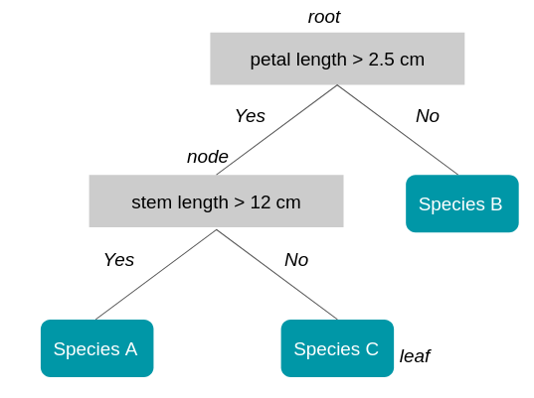

The tree has a depth of 2 (one node plus the root). The length of the petal is the first measure that is used because it best separates the 4 observations according to class membership (here class B).

***2. “Random Forests”***

As the name might suggest, the random forest algorithm is based on a multitude of decision trees.

In order to understand better the advantages and logic of this algorithm, let’s start with an example:

You are looking for a good travel destination for your next vacation. You ask your best friend for his opinion. He asks you questions about your previous trips and makes a recommendation.

You decide to ask a group of friends who ask you questions randomly. They each make a recommendation. The chosen destination is the one that has been the most recommended by your friends.

The recommendations made by your best friend and the group will both make good destination choices. But when the first recommendation method works very well for you, the second will be more reliable for other people.

This comes from the fact that your best friend, who builds a decision tree to give you a destination recommendation, knows you very well what making the decision tree over-learned about you (we talk about overfitting).

Your friend group represents the random forest of multiple decision trees and it’s a model, when used properly, avoids the pitfall of overfitting. How is this forest built?

Here are the main steps:

1. We take a number X of observations from the starting dataset (with discount).

2. We take a number K of the M variables available (features), for example: only temperature and population density

3. We create a decision tree on this dataset.

4. Steps 1. to 4. are repeated N times so as to obtain N trees.

To obtain the class of a new observation we go down the N trees. Each tree will predict a different class. The class chosen is the one that is most represented among all the trees in the forest. (Majority vote / ‘Ensemble’).

***3. The “Gradient Boosting” / “XG Boost”***

The boosting gradient method is used to reinforce a model that produces weak predictions, such as a decision tree (see below how do we judge the quality of a model).

We will explain the principle of boosting gradient with the decision tree but this could be with another model.

You have an individual database with demographics information and past activities. You have 50% of individuals their age but the other half is unknown.

You want to get the age of a person according to his activities: food shopping, television, gardening, video games … You choose as a model a decision tree, in this case it is a regression tree because the value to predict is numeric.

Your first regression tree is satisfying but can be improved: it predicts, for example, that an individual is 19 years old when in fact he is 13 years old, and for another 55 years old instead of 68 years old.

The principle of the gradient boosting is that you will redo a model on the difference between the predicted value and the true value to be predicted.

|  |  |  |  |
| --- | --- | --- | --- |
| Age | Prediction Tree 1 | Difference | Prediction Tree 2 |
| 13 | 19 | -6 | 15 |
| 68 | 55 | +13 | 63 |

This step N is repeated where N is determined by successively minimizing the error between the prediction and the true value.

The method to optimize is the gradient descent method that we will not explain here. The XG Boost (eXtreme Gradient Boosting) model is one of the implementations of the boosting gradient founded by Tianqi Chen and has seduced the Kaggle datascientist community with its efficiency and performance. The publication explaining the algorithm is here.

***4. “Genetic Algorithms”***

As their name suggests genetic algorithms are based on the process of genetic evolution that has made us who we are …

More prosaically they are mainly used when there are no observations of departure and it is hoped that a machine will learn to learn as and when testing.

These algorithms are not the most effective for a specific problem but rather for a set of subproblems (eg learning balance and walking in robotics).

Let’s take a simple example: We want to find the code of a safe that is made of 15 letters: “MACHINELEARNING”

The genetic algorithm approach will be as follows:

We start from a population of 10,000 “chromosomes” of 15 letters each. We say that the code is a word or a set of words pro

“DEEP-LEARNING”

“STATISTICAL INFERENCE-“

“HUMAN MACHINE INTERFACE” etc.

We will define a method of reproduction: for example, to combine the beginning of one chromosome with the end of another.

Ex: “DEEP-LEARNING” + “STATISTICAL-INFERENCE” = “DEEP-INFERENCE”

Then we will define a mutation method which allows to change a progeny that is blocked. In our case it could be to vary one of the letters randomly. Finally we define a score that will reward such or such descendants of chromosomes. In our case where the code is hidden we can imagine a sound that the trunk would do when 80% of the letters are similar and that would become stronger as we approach the right code.

Our genetic algorithm will start from the initial population and form chromosomes until the solution has been found.

***5. “Support Vector Machines”***

Also known as “SVM” this algorithm is mainly used for classification problems even though it has been extended to regression problems (Drucker et al., 96).

Let’s take our example of ideal holiday destinations. For the simplicity of our example consider only 2 variables to describe each city: the temperature and the density of population. We can therefore represent cities in 2 dimensions.

We represent by circles cities which you very much appreciated and by squares those which you least appreciated. When you consider new cities you want to know which group this new city is closest to.

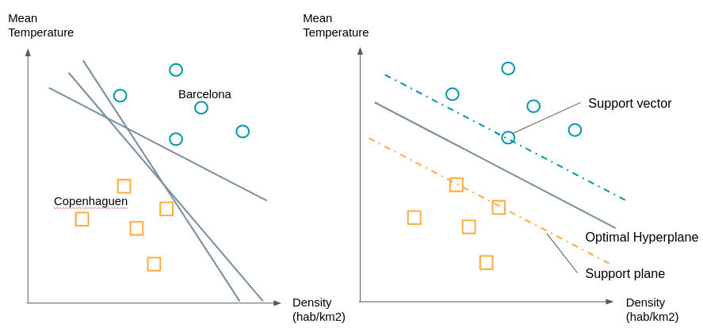***SVM Example***

As we see in the graph on the right, there are many plans (straight lines when you only have 2 dimensions) that separate the two groups.

We will choose the line that is at the maximum distance between the two groups. To build it we already see that we do not need all the points, it is enough to take the points which are at the border of their group we call these points or vectors, the support vectors. The planes passing through these support vectors are called support planes. The separation plan will be the one that will be equidistant from the two supporting planes.

What to do if the groups are not so easily separable, for example if by one of the dimensions circles are mixed up with squares or vice-versa?

We will proceed to a transformation of these points by a function to be able to separate them. As in the example below:

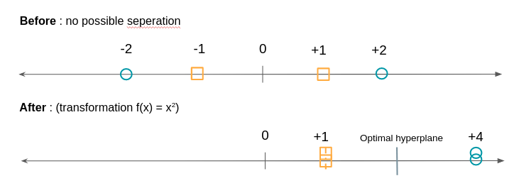**SVM transformation example**

The SVM algorithm will therefore consist of looking for both the optimal hyperplane and minimizing classification errors.

***6. The “K nearest neighbors”***

Pause. After 5 relatively technical models the algorithm of the K nearest neighbors will appear to you as a formality. Here’s how it works:

An observation is assigned the class of its nearest K neighbors.

“That’s it ?!” you might ask me.

Yes that’s all. Only as the following example shows: K’s choice can matter a lot.

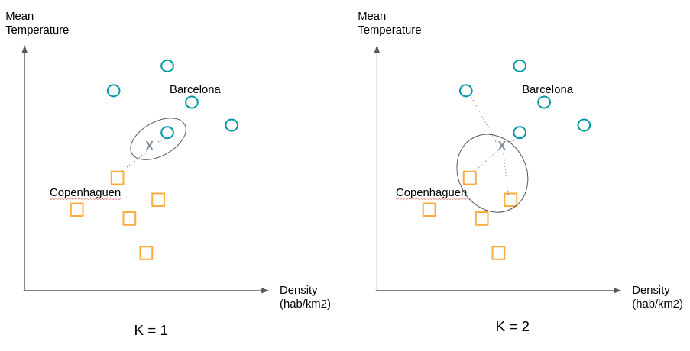K

nearest neighbours

We will typically try different values ​​of K to obtain the most satisfactory separation.

**7. “Logistic Regression”**

Let’s start by a reminder of linear regression. Linear regression is used to predict a numerical variable, e.g the price of cotton in relation to other numeric or binary variables: the number of cultivable hectares, the demand for cotton from various industries, and so on.

It is a question of finding the coefficients a1, a2, … in order to have the best estimate:

Cotton price = a1 * Number of hectares + a2 * Demand for cotton + …

Logistic regression is used in classification in the same way as the algorithms exposed so far. Once again let’s take the example of trips considering only two classes: good destination (Y = 1) and bad destination (Y = 0).

P (1): probability the city is a good destination.

P (0): probability that the city is a bad destination.

The city is represented by a number of variables, we will only consider two: the temperature and population density.

* X = (X1: temperature, X2: population density)

We are therefore interested in building a function that gives us for a city X:

* P (1 | X): probability that the destination is good knowing X, which is to say probability that the city checking X is a good destination.

We would like to relate this probability to a linear combination as a linear regression. Only the probability P (1 | X) varies between 0 and 1 except we want a function that traverses the whole domain of real numbers (from -infinite to + infinity).

For that we will start by considering P (1 | X) / (1 – P (1 | X)) which is the ratio between the probability that the destination is good and that the destination is bad.

For strong probabilities this ratio approaches + infinity (for example a probability of 0.99 gives 0.99 / 0.01 = 99) and for low probabilities it approaches 0: (a probability of 0.01 gives 0.01 / 0.99 = 0.0101 ).

We went from [0,1] to [0, + infinite [. To extend the ‘scope’ of the possible values ​​to] -infinite, 0] we take the natural logarithm of this ratio.

It follows that we are looking for b0, b1, b2, … such as:

* ln (P (1 | X) / (1-P (1 | X)) = b0 + b1X1 + b2X2

The right part represents the regression and the logarithm of Neperian denotes the logistic part.

The logistic regression algorithm will therefore find the best coefficients to minimize the error between the prediction made for visited destinations and the true label (good, bad) given.

***8. “Clustering”***

Supervised vs. Unsupervised learning. Do you remember?

Until now we have described supervised learning algorithms. Classes are known and we want to classify or predict a new observation. But how to do when there is no predefined group? When you are looking for patterns shared by groups of people?

Here comes unsupervised learning and clustering algorithms.

Take the example of a company that started its digital transformation. It has new sales and communication channels through its site and one or more associated mobile applications. In the past, it was addressing it’s clients based on demographics and their purchase history. But how to exploit the navigation data of its customers? Does online behavior match classic customer segments?

These questions can motivate the use of clustering to see if major trends are emerging. This will invalidate or confirm business intuitions that you may have.

There are many clustering algorithms (hierarchical clustering, k-means, DBSCAN, …). One of the most used is the k-means algorithm. We will explain the operation simply:

Even if we do not know how the clusters will be constituted, the k-means algorithm imposes to give the expected number of clusters. Techniques exist to find the optimal number of clusters.

Consider the example of cities. Our dataset has 2 variables, so we have 2 dimensions. After a first study we expect to have 2 clusters. We begin by randomly placing two points; they represent our starter ‘means’. We associate with the same clusters the observations closest to these means. Then we calculate the average of the observations of each cluster and move the means to the computed position. We re-assign the observations to the nearest means and so on.

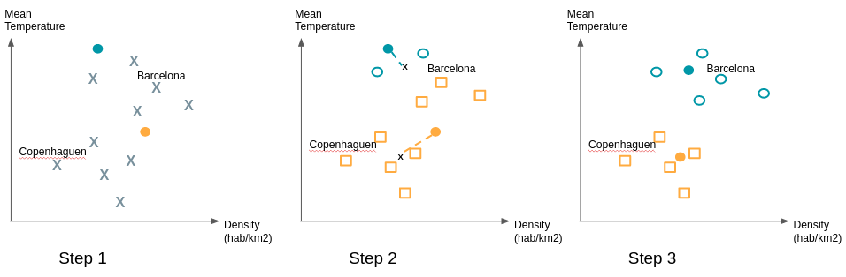

To ensure the stability of the groups found it is recommended to repeat the draw of the initial ‘means’ several times because some initial draws may give a configuration different from the vast majority of cases***.***

***Factors of Relevance and Quality of Machine Learning Algorithms***

Machine learning algorithms are evaluated on the basis of their ability to correctly classify or predict both the observations that were used to train the model (training and test game) but also and especially observations for which the label or value is known and has not been used in the development of the model (validation set).

Proper classification implies both placing the observations in the correct group and at the same time not placing them in the wrong groups.

The chosen metric may vary depending on the intent of the algorithm and its business usage.

Several data factors can play a big role in the quality of the algorithms. Here are the main ones:

1. The number of observations:

* the fewer observations there are, the more difficult the analysis,
* but the more there is, the more the need for computer memory is high and the longer is the analysis)

2. The number and quality of attributes describing these observations

For example the distance between two numeric variables (price, size, weight, light intensity, noise intensity, etc.) is easy to establish, that between two categorical attributes (color, beauty, utility …) is more delicate;

3. The percentage of data filled in and missing

4. “Noise”: the number and “location” of dubious values ​​(potential errors, outliers …) or of course not conforming to the pattern of general distribution of “examples” on their distribution space will have an impact on the quality of the ‘analysis.

Conclusion

**We have seen that machine learning algorithms serve two purposes: classifying and predicting and are divided into supervised and unsupervised algorithms. There are many possible algorithms, we have covered 8 of them including logistic regression and random forests to classify an observation and clustering to bring out homogeneous groups from the data. We also saw that the value of an algorithm depended on the associated cost or loss function but that its predictive power depended on several factors related to the quality and volume of data.**

**I hope this article has given you some insight into what is called Machine Learning. Feel free to use the comment section to get back to me on aspects that you would like to clarify or deepen.**

1. Applications of Machine learnings ?

1. Virtual Personal Assistants

Siri, Alexa, Google Now are some of the popular examples of virtual personal assistants. As the name suggests, they assist in finding information, when asked over voice. All you need to do is activate them and ask “What is my schedule for today?”, “What are the flights from Germany to London”, or similar questions. For answering, your personal assistant looks out for the information, recalls your related queries, or send a command to other resources (like phone apps) to collect info. You can even instruct assistants for certain tasks like “Set an alarm for 6 AM next morning”, “Remind me to visit Visa Office day after tomorrow”.

Machine learning is an important part of these personal assistants as they collect and refine the information on the basis of your previous involvement with them. Later, this set of data is utilized to render results that are tailored to your preferences.

Virtual Assistants are integrated to a variety of platforms. For example:

* Smart Speakers: Amazon Echo and Google Home
* Smartphones: Samsung Bixby on Samsung S8
* Mobile Apps: Google Allo

2. Predictions while Commuting

Traffic Predictions: We all have been using GPS navigation services. While we do that, our current locations and velocities are being saved at a central server for managing traffic. This data is then used to build a map of current traffic. While this helps in preventing the traffic and does congestion analysis, the underlying problem is that there are less number of cars that are equipped with GPS. Machine learning in such scenarios helps to estimate the regions where congestion can be found on the basis of daily experiences.

Online Transportation Networks: When booking a cab, the app estimates the price of the ride. When sharing these services, how do they minimize the detours? The answer is machine learning. Jeff Schneider, the engineering lead at Uber ATC reveals in a an interview that they use ML to define price surge hours by predicting the rider demand. In the entire cycle of the services, ML is playing a major role.

3. Videos Surveillance

Imagine a single person monitoring multiple video cameras! Certainly, a difficult job to do and boring as well. This is why the idea of training computers to do this job makes sense.

The video surveillance system nowadays are powered by AI that makes it possible to detect crime before they happen. They track unusual behaviour of people like standing motionless for a long time, stumbling, or napping on benches etc. The system can thus give an alert to human attendants, which can ultimately help to avoid mishaps. And when such activities are reported and counted to be true, they help to improve the surveillance services. This happens with machine learning doing its job at the backend.

4. Social Media Services

From personalizing your news feed to better ads targeting, social media platforms are utilizing machine learning for their own and user benefits. Here are a few examples that you must be noticing, using, and loving in your social media accounts, without realizing that these wonderful features are nothing but the applications of ML.

* People You May Know: Machine learning works on a simple concept: understanding with experiences. Facebook continuously notices the friends that you connect with, the profiles that you visit very often, your interests, workplace, or a group that you share with someone etc. On the basis of continuous learning, a list of Facebook users are suggested that you can become friends with.
* Face Recognition: You upload a picture of you with a friend and Facebook instantly recognizes that friend. Facebook checks the poses and projections in the picture, notice the unique features, and then match them with the people in your friend list. The entire process at the backend is complicated and takes care of the precision factor but seems to be a simple application of ML at the front end.
* Similar Pins: Machine learning is the core element of Computer Vision, which is a technique to extract useful information from images and videos. Pinterest uses computer vision to identify the objects (or pins) in the images and recommend similar pins accordingly.

5. Email Spam and Malware Filtering

* There are a number of spam filtering approaches that email clients use. To ascertain that these spam filters are continuously updated, they are powered by machine learning. When rule-based spam filtering is done, it fails to track the latest tricks adopted by spammers. Multi Layer Perceptron, C 4.5 Decision Tree Induction are some of the spam filtering techniques that are powered by ML.
* Over 325, 000 malwares are detected everyday and each piece of code is 90–98% similar to its previous versions. The system security programs that are powered by machine learning understand the coding pattern. Therefore, they detects new malware with 2–10% variation easily and offer protection against them.

6. Online Customer Support

A number of websites nowadays offer the option to chat with customer support representative while they are navigating within the site. However, not every website has a live executive to answer your queries. In most of the cases, you talk to a chatbot. These bots tend to extract information from the website and present it to the customers. Meanwhile, the chatbots advances with time. They tend to understand the user queries better and serve them with better answers, which is possible due to its machine learning algorithms.

7. Search Engine Result Refining

Google and other search engines use machine learning to improve the search results for you. Every time you execute a search, the algorithms at the backend keep a watch at how you respond to the results. If you open the top results and stay on the web page for long, the search engine assumes that the the results it displayed were in accordance to the query. Similarly, if you reach the second or third page of the search results but do not open any of the results, the search engine estimates that the results served did not match requirement. This way, the algorithms working at the backend improve the search results.

8. Product Recommendations

You shopped for a product online few days back and then you keep receiving emails for shopping suggestions. If not this, then you might have noticed that the shopping website or the app recommends you some items that somehow matches with your taste. Certainly, this refines the shopping experience but did you know that it’s machine learning doing the magic for you? On the basis of your behaviour with the website/app, past purchases, items liked or added to cart, brand preferences etc., the product recommendations are made.

9. Online Fraud Detection

Machine learning is proving its potential to make cyberspace a secure place and tracking monetary frauds online is one of its examples. For example: Paypal is using ML for protection against money laundering. The company uses a set of tools that helps them to compare millions of transactions taking place and distinguish between legitimate or illegitimate transactions taking place between the buyers and sellers.

1. Types of Artificial Intelligence?

There are four types of Artificial Intelligence

### TYPE I AI: REACTIVE MACHINES

The most basic types of AI systems are purely reactive, and have the ability neither to form memories nor to use past experiences to inform current decisions. [Deep Blue, IBM’s chess-playing supercomputer](http://www.techrepublic.com/article/ibm-watson-the-inside-story-of-how-the-jeopardy-winning-supercomputer-was-born-and-what-it-wants-to-do-next/), which beat international grandmaster Garry Kasparov in the late 1990s, is the perfect example of this type of machine.

Deep Blue can identify the pieces on a chess board and know how each moves. It can make predictions about what moves might be next for it and its opponent. And it can choose the most optimal moves from among the possibilities.

But it doesn’t have any concept of the past, nor any memory of what has happened before. Apart from a rarely used chess-specific rule against repeating the same move three times, Deep Blue ignores everything before the present moment. All it does is look at the pieces on the chess board as it stands right now, and choose from possible next moves.

This type of intelligence involves the computer [perceiving the world directly](https://www.youtube.com/watch?v=t3kXWSctj2Q)and acting on what it sees. It doesn’t rely on an internal concept of the world. In a seminal paper, AI researcher Rodney Brooks argued that [we should only build machines](http://dx.doi.org/10.1016/0004-3702(91)90053-M) like this. His main reason was that people are not very good at programming accurate simulated worlds for computers to use, what is called in AI scholarship a “representation” of the world.

The current intelligent machines we marvel at either have no such concept of the world, or have a very limited and specialized one for its particular duties. The [innovation in Deep Blue’s design](https://www.scientificamerican.com/article/how-the-computer-beat-the-go-master/) was not to broaden the range of possible movies the computer considered. Rather, the developers found a way to narrow its view, to [stop pursuing some potential future moves](https://www.cnet.com/news/did-a-bug-in-deep-blue-lead-to-kasparovs-defeat/), based on how it rated their outcome. Without this ability, Deep Blue would have needed to be an even more powerful computer to actually beat Kasparov.

Similarly, Google’s AlphaGo, which has beaten top human Go experts, can’t evaluate all potential future moves either. Its analysis method is more sophisticated than Deep Blue’s, using a [neural network](http://pages.cs.wisc.edu/~bolo/shipyard/neural/local.html) to evaluate game developments.

These methods do improve the ability of AI systems to play specific games better, but they can’t be easily changed or applied to other situations. These computerized imaginations have no concept of the wider world – meaning they can’t function beyond the specific tasks they’re assigned and are [easily fooled](http://dx.doi.org/10.1109/CVPR.2015.7298640).

They can’t interactively participate in the world, the way we imagine AI systems one day might. Instead, these machines will behave exactly the same way every time they encounter the same situation. This can be very good for ensuring an AI system is trustworthy: You want your autonomous car to be a reliable driver. But it’s bad if we want machines to truly engage with, and respond to, the world. These simplest AI systems won’t ever be bored, or interested, or sad.

### TYPE II AI: LIMITED MEMORY

This Type II class contains machines can look into the past. Self-driving cars do some of this already. For example, they observe other cars’ speed and direction. That can’t be done in a just one moment, but rather requires identifying specific objects and monitoring them over time.

These observations are added to the self-driving cars’ preprogrammed representations of the world, which also include lane markings, traffic lights and other important elements, like curves in the road. They’re included when the car decides when to change lanes, to avoid cutting off another driver or being hit by a nearby car.

But these simple pieces of information about the past are only transient. They aren’t saved as part of the car’s library of experience it can learn from, the way human drivers compile experience over years behind the wheel.

So how can we build AI systems that build full representations, remember their experiences and learn how to handle new situations? Brooks was right in that it is very difficult to do this. My own research into methods inspired by Darwinian evolution can start to [make up for human shortcomings](http://dx.doi.org/10.1162/NECO_a_00475) by letting the machines build their own representations.

### TYPE III AI: THEORY OF MIND

We might stop here, and call this point the important divide between the machines we have and the machines we will build in the future. However, it is better to be more specific to discuss the types of representations machines need to form, and what they need to be about.

Machines in the next, more advanced, class not only form representations about the world, but also about other agents or entities in the world. In psychology, this is called “[theory of mind](http://dx.doi.org/10.1017/S0140525X00076512)” – the understanding that people, creatures and objects in the world can have thoughts and emotions that affect their own behavior.

This is crucial to [how we humans formed societies](https://theconversation.com/can-great-apes-read-your-mind-66224), because they allowed us to have social interactions. Without understanding each other’s motives and intentions, and without taking into account what somebody else knows either about me or the environment, working together is at best difficult, at worst impossible.

If AI systems are indeed ever to walk among us, they’ll have to be able to understand that each of us has thoughts and feelings and expectations for how we’ll be treated. And they’ll have to adjust their behavior accordingly.

### TYPE IV AI: SELF-AWARENESS

The final step of AI development is to build systems that can form representations about themselves. Ultimately, we AI researchers will have to not only understand consciousness, but build machines that have it.

This is, in a sense, an extension of the “theory of mind” possessed by Type III artificial intelligences. Consciousness is also called “self-awareness” for a reason. (“I want that item” is a very different statement from “I know I want that item.”) Conscious beings are aware of themselves, know about their internal states, and are able to predict feelings of others. We assume someone honking behind us in traffic is angry or impatient, because that’s how we feel when we honk at others. Without a theory of mind, we could not make those sorts of inferences.

While we are probably far from creating machines that are self-aware, we should focus our efforts toward understanding memory, learning and the ability to base decisions on past experiences. This is an important step to understand human intelligence on its own. And it is crucial if we want to design or evolve machines that are more than exceptional at classifying what they see in front of them.

1. Applications and Examples of AI

Various Applications and Example of AI are :

a. Virtual Personal Assistants

Basically, it is processed in which we have to collect a huge amount data. That is collected from a variety of sources to learn about users. Also, one needs to be more effective in helping them organize and track their information.

For Example:

There are various platforms like iOS, Android, and Window mobile. We use intelligent digital personal assistants are like Siri, Google Now, and Cortana.

AI plays an important role in this apps. If you demand they use to collect the information. And this information is used to recognize your request and serves your result.

b. Smart Cars

There are two examples:

That are featured Google’s self-driving car project and Tesla’s “autopilot”. Also. the artificial intelligence is been used since the invention of the first video game.

c. Prediction

We call it as the use of predictive analytics. Its main purpose is potential privacy. Also, we can use in many ways. As its also sending you coupons, offering you discounts. That are close to your home with products that you will like to buy. Further, we can call it as the controversial use of artificial intelligence.

d. Fraud Detection

We use AI to detects fraud. As many frauds always happen in banks. AI is often the technology deployed to monitor for this type of fraud. Also, computers has a large sample of fraudulent and non-fraudulent purchases. As they asked to look for signs that a transaction falls into one category or another.

e. Pandora

We know its most popular and highly demanded tech solutions. Also, called the DNA of music.

f. Boxever

Basically, it is a type of company. Also, it relies on machine learning. That’s to enhance the customer experience in the travel industry.

preventing heart attacks

Nowadays we use artificial intelligence to save lives. As we use it to scan medical data. Also, help in predicting if a patient is susceptible to heart attacks and strokes.

g. Online Customer Support

As artificial intelligence plays an important role in online customer support. As many websites have an option of live chat for their customers. In many cases, you’re talking to a rudimentary AI.

Perhaps, these chat bots need to understand natural language. I.e language human understands and the language computer understands is very different. But with rapid advances in natural processing , these bots are getting better all the time.

h. News Generation

A news generation is a common topic all the times. As we use artificial intelligence in news generation for the different purposes.

As A.I is used to write simple stories like financial summaries, sports. Also, artificial intelligence doesn’t use to write in-depth investigative articles. Although, it is not having a problem with simple articles that don’t require a lot of syntheses.

Also, e-commerce, financial services, other “data-driven” industries are already benefiting from the app.

i. Security Surveillance

Monitoring a number of video cameras by a single person is not a secure system. Although, people easily get bored. Moreover, keeping all those at the same time is not an easy task.

Thus, supervised training exercises, security algorithm can take input from the security cameras. As it happens to determine whether there may be a threat.

There is a limitation in identifying actions. That are might imply a thief in a store is likely beyond the current technology. Although, if there is sort of technologies, then don’t be surprised.

j. Music and Movie Recommendation Services

It’s simple when compared to other AI systems. While they’re rather simple when compared to other AI systems. We use a learning algorithm to make our choice on a monitor. It’s proof that you are interested in it.

k. SIRI

Basically, machine Learning technology is used by Siri users. Also, they use it to get understand natural language questions and requests.

l. TESLA

Tesla is something you are missing if you are a car geek. Also, this is one of the best automobiles available until now.

m. Cogito

Dr. Sandy and Joshua have found the Cogito. Also, the behavioral version to improve the intelligence of customer support representatives.

Smart Home Devices

For lighting, we use artificial intelligence. Also, lighting is another place where you might see basic artificial intelligence. Although by setting defaults and preferences, the lights around your house might adjust. That is based on where you are and what you’re doing.

For example:

The uses of AI in smart homes are limited only by our imagination.

n. AI: Serving Millions Daily

As we use smartphone, car, bank, and house. That on a daily basis we use AI for all these purposes. AI is everywhere, and it’s making a huge difference in our lives every day.

o. Manufacturing

Basically, AI is used in manufacturing company from the very beginning. Also, we use automobiles and electronic to manufactured goods. As we use AI to make more modifications.

Home Appliances

Further, we use too many smart devices and gadgets used in our daily lives. That feature IoT technology also makes use of Artificial Intelligence.

p. Engineering Design & Camical Analysis

Basically, used to design expert drawings and Camical synthesis.

q. Heuristic Classification

The term Heuristic means to Find & Discover., find the problem and discover the solution. Hence, we use AI for this purpose.

r. Customer Service

As there are so many websites are present which are providing us live chat option. Also, its one of the ubiquitous applications of artificial intelligence.

Moreover, to teach a machine is not so easy. Rapid advances in natural processing means they are getting better all the time.

s. Cybersecurity

It’s a quite big challenge to find gaps in the cyber defense. Although, it’s a normal process. As attackers spend months and years to develop hacks.

Moreover, the great thing about this is that it discovered a new attack in form of binary code. As it works what it was doing. Then it returns the breached and the favor the attacker’s defenses.

t. Search and Rescue

Sifting through footage and photo it’s very time consuming. Although, mean someone dies before help can arrive.

We use applications of artificial intelligence to disaster events for finding stranded survivors. Moreover, drones are in use to fund the footage. It can even find piles of debris in flooded areas that may have trapped victims in them.

AI can also analyze social media like Twitter to learn about who is missing during disasters.

u. Identifying criminals

We use machine-vision algorithms to achieve the goal. Also, AI uses photos of suspects and real criminals all without facial hair.

Some of the traits found by the AI included:

inner corner distances of their eyes

specific lip curvatures and;

v. Pandora

We know its most popular and highly demanded tech solutions. Also, called the DNA of music.

w. Boxever

Basically, it is a type of company. Also, it relies on machine learning. That’s to enhance the customer experience in the travel industry.

x. Preventing heart attacks

Nowadays we use artificial intelligence to save lives. As we use it to scan medical data. Also, help in predicting if a patient is susceptible to heart attacks and strokes.

y. Treatment Design and journalism

Treatment– Basically, we use AI systems in treatment design to create and analyze data.

Journalism –Articles and reports that do not require too much analysis are prepared by AI in journalism. As they need less time do this.

For Examples-

Companies- AP and Yahoo! we use AI in both companies to prepare a report related to sports. Also, AI helps in an election that takes too much time to do manually.

z. Online Retail Stores

Basically, we use AI in online retail stores in certain ways.

Although, depending on the choice of customer what to purchase items. That need to put in a search box.

Also, providing chat box for solving problems. Well, it will be interesting to see what the future holds for the online retail stores.

1. What is deep learning ?

Deep learning is a machine learning technique that teaches computers to do what comes naturally to humans: learn by example. Deep learning is a key technology behind driverless cars, enabling them to recognize a stop sign, or to distinguish a pedestrian from a lamppost. It is the key to voice control in consumer devices like phones, tablets, TVs, and hands-free speakers. Deep learning is getting lots of attention lately and for good reason. It’s achieving results that were not possible before.

In deep learning, a computer model learns to perform classification tasks directly from images, text, or sound. Deep learning models can achieve state-of-the-art accuracy, sometimes exceeding human-level performance. Models are trained by using a large set of labeled data and neural network architectures that contain many layers.

### Examples of Deep Learning at Work

Deep learning applications are used in industries from automated driving to medical devices.

Automated Driving: Automotive researchers are using deep learning to automatically detect objects such as stop signs and traffic lights. In addition, deep learning is used to detect pedestrians, which helps decrease accidents.

Aerospace and Defense: Deep learning is used to identify objects from satellites that locate areas of interest, and identify safe or unsafe zones for troops.

Medical Research: Cancer researchers are using deep learning to automatically detect cancer cells. Teams at UCLA built an advanced microscope that yields a high-dimensional data set used to train a deep learning application to accurately identify cancer cells.

Industrial Automation: Deep learning is helping to improve worker safety around heavy machinery by automatically detecting when people or objects are within an unsafe distance of machines.

Electronics: Deep learning is being used in automated hearing and speech translation. For example, home assistance devices that respond to your voice and know your preferences are powered by deep learning applications.

1. GOALS of AI

While people here have talked of "strong AI" and exceeding human intelligence (Turing test), there is also another perspective, which is that the goal of AI is to build a [Rational agent](http://en.wikipedia.org/wiki/Rational_agent). The reason why people sometimes don't really want to define AI in terms of human intelligence is because, frankly, humans are not intelligent. They can't handle evidence, they keep making errors of logic and so on and so forth. Being more human-like is also often not really a quantifiable goal : a better goal is to be optimal in what you do, where "optimal" is defined as maximizing your utility given whatever you know. Let me now talk of where AI started and how it is going  
  
Initial attempts involved trying to make the computer follow logic, verify proofs, play Chess and tic-tac-toe, things like that. As it turns out, playing games and following logic, which is somewhat hard for us humans, is actually very easy to do for a computer. As an example, it is almost trivial to code up a sudoku solver that runs in a few seconds, while I take a few minutes to solve Sudoku myself. The conclusion was, to quote Minsky (one of the early greats in the field) backin 1977:  
“Our first foray into Artificial Intelligence was a program that did a credible job of solving problems in college calculus. Armed with that success, we tackled high school algebra; we found, to our surprise, that it was much harder. Attempts at grade school arithmetic provide problems of current research interest. An exploration of the child’s world of blocks proved insurmountable, except under the most rigidly constrained circumstances.  
It finally dawned on us that the overwhelming majority of what we call intelligence is developed by the end of the first year of life.”  
  
As such the biggest problems in the field are those that "three year olds can do": things like walk, sense, see, pick up language and grammar, grasp and manipulate unseen objects, recognize what it is seeing and so forth. This has been one big departure from the early days, what is now called "classical AI". This is not to say that classical AI is gone; it is just not the only thing now.  
  
A second major breakthrough was the advent of statistics and machine learning. There is no way you could overestimate the impact of statistics. Statistics and probability allowed us to handle uncertainty, and many, if not all, fields of AI were  (I think I can safely say) revolutionized by its impact. And notwithstanding many remarks I have seen, the impact was great enough to yield very practical systems, something that old school AI couldn't really do. Almost everything from your cell phone camera to your Netflix account to even perhaps aspects of Quora itself are probably driven by machine learning.   
  
And how close are we to the true goal, building a rational agent? Far away, but we are making measured, quantifiable progress. We no longer make blatant claims of grandeur; the [AI winter](http://en.wikipedia.org/wiki/AI_winter) has mellowed us somewhat :). We might not have a full-fledged robotic human-like agent anytime soon, but it won't be a stretch to say that you will soon be interacting with AI's every day of your life, if not already.

The long-term goals of AI include finding out what the world is like, understanding it, and changing it, or, in other words,

* + empirical study and modelling of existing intelligent systems (mainly human beings);
  + theoretical analysis and exploration of possible intelligent systems and possible mechanisms and representations usable by such systems; and
  + solving practical problems in the light of (a) and (b), namely:
  + attempting to deal with problems of existing intelligent systems (e.g., problems of human learning or emotional difficulties) and
  + designing useful new intelligent or semi intelligent machines.

Some people restrict the term `artificial intelligence' to a subset of this wide-ranging discipline. For example, those who think of it as essentially a branch of engineering restrict it to (c.2). This does not do justice to the full range of work done in the name of AI.

In any case, it is folly to try to produce engineering solutions without either studying general underlying principles or investigating the existing intelligent systems on which the new machines are to be modelled or with which they will have to interact. Trying to build intelligent systems without trying to understand general principles would be like trying to build an aeroplane without understanding principles of mechanics or aerodynamics. Trying to build them without studying how people or other animals work would be like trying to build machines without ever studying the properties of any naturally occurring object.

1. Tools of AI

#### 🔉 Audio

[**Capio**](http://www.capio.ai/) — language transcription and recognition  
[**Clover Intelligence**](https://cloverintelligence.com/) — ?  
[**Deepgram**](https://www.deepgram.com/)— transcribes insights from phone calls, video footage, and online  
[**Gridspace**](https://www.gridspace.com/) — discover more customer and employee conversations  
[**MindMeld**](https://www.mindmeld.com/)— advanced AI to power conversational interface  
[**Nexidia**](http://www.nexidia.com/)— turns customer interactions into valuable insights  
[**Pop Up Archive**](https://www.popuparchive.com/)— makes sound searchable  
[**TalkIQ**](https://www.talkiq.com/)— critical insights about your customers conversations  
[**Twilio**](https://www.twilio.com/)— building blocks to add messaging, voice, and video to web+apps

#### 📊 Business Intelligence & Analytics

[**Arago/HIRO**](https://www.arago.co/hiro/) — optimise and autonomously IT and business operations [**Arimo**](https://arimo.com/) —behavioural AI for IoT  
[**Ayasdi**](https://www.ayasdi.com/)— a suite of intelligent applications for enterprise  
[**DataRobot**](https://www.datarobot.com/) — a range of products to improve enterprise products  
[**Dataminr**](https://www.dataminr.com/)— discovers events and breaking information before the news  
[**Electra by Lore**](http://www.lore.ai/electra/) — helps you to answer questions about your business  
[**Einstein**](https://www.salesforce.com/au/products/einstein/overview/) — a smarter Salesforce  
[**Fuzzy AI**](https://fuzzy.ai/) — adds intelligent decision making to web and mobile apps  
[**Logz.io**](http://logz.io/)— helps you index, search, visualise and analyse your data  
[**NXT AI**](https://nxt.ai/) — is a framework for temporal pattern recognition and prediction  
[**Paxata**](http://www.paxata.com/)— to transform raw data into useful information automatically  
[**Poweredby.ai**](https://poweredby.ai/)— helps you monitor server bugs  
[**Sundown**](https://www.sundown.ai/home/) — automates repetitive tasks within your business  
[**UBIX**](http://ubix.ai/#dynamic) — making complex data science easy for enterprise

[*Ruths.ai*](http://ruths.ai/)*— helps you do more with your data*  
[*Exchange.ai*](http://exchange.ai/)*— a marketplace for analytics*  
[*Owl.ai*](http://owl.ai/)*— captures, categorises, and extracts key information from all your data*  
[*AnswerRocket*](http://answerrocket.com/)*— fast data insights using search*  
[*iSeek.ai*](http://iseek.ai/)*— solves big data better, faster and at less cost*  
[*Ecosystem.AI*](http://ecosystem.ai/)*— find hidden value in complex human and business ecosystems*  
[*Prix*](https://www.prix.ai/)*— helps to optimise pricing*

#### 🍎 Core AI

[**Algorithmia**](https://algorithmia.com/) — a common API for many algorithms, functions and models  
[**Arya**](https://arya.ai/) — workbench for neural networks  
[**CognitiveScale**](https://www.cognitivescale.com/) — advanced industry specific ML for the enterprise  
[**Digital Reasoning**](http://www.digitalreasoning.com/) — advanced machine learning for enterprise  
[**Fluid AI**](http://fluid.ai/)— advanced machine learning for enterprise  
[**H2O.ai**](http://h2o.ai/) — open source machine learning and deep learning platform  
[**Loop AI Labs**](http://www.loop.ai/) — advanced machine learning for enterprise  
[**Nervana**](https://www.nervanasys.com/) — deep learning as computational system  
[**Petuum**](http://www.petuum.com/) — advanced machine learning for enterprise  
[**Scaled Inference**](https://www.scaledinference.com/)— advanced machine learning for enterprise  
[**Sentient**](http://www.sentient.ai/) — range of financial, ecommerce and digital marketing AI products  
[**Skymind**](https://skymind.io/)— open-source deep learning and ETL for enterprise on the JVM  
[**Vicarious**](http://www.vicarious.com/)— advanced machine learning for enterprise  
[**Loom Systems**](https://www.loomsystems.com/)— log Analysis for enterprises

[*PipelineAI*](http://pipeline.ai/index.html)*— solves the problem of production ML and AI at scale*  
[*Ogma*](https://ogma.ai/)*— building AI using neuroscience*

#### 📋 Data Capture

[**Amazon Mechanical Turk**](https://www.mturk.com/mturk/welcome) — marketplace to automate simple processes  
[**CrowdAI**](http://crowdai.com/) — automate the discovery of objects at scale  
[**Datalogue**](https://about.datalogue.io/) — automatically prepare any data for immediate & compliant use  
[**DataSift**](http://datasift.com/) — helps structure data from social media and blog  
[**Diffbot**](https://www.diffbot.com/) — automatically extract web pages as structured data  
[**Import.io**](http://import.io/)— extract data from almost any website  
[**Playment**](https://playment.io/)— training data, image annotation and more for enterprise  
[**WorkFusion**](https://www.workfusion.com/) — tools for operations team to automate business processes

#### 🔬 Data Science

[**BigML**](https://bigml.com/) — single platform for all predictive use cases  
[**CrowdFlower**](https://www.crowdflower.com/) — training data, image annotation for machine learning teams  
[**Dataiku**](http://www.dataiku.com/) — data science platform for prototype, deploy, and run at scale  
[**DataScience**](https://www.datascience.com/) — enterprise data science platform for R&D and production  
[**Domino Data Lab**](https://www.dominodatalab.com/)— platform for collaborating, building and deploying  
[**Exploratory**](https://exploratory.io/)— makes DS accessible to analysts with OpenSource algorithms  
[**Kaggle**](https://www.kaggle.com/) — helps you learn, work, and play with machine learning models  
[**RapidMiner**](https://rapidminer.com/)— makes data science teams more productive  
[**Seldon**](http://www.seldon.io/) — helps DS teams put machine learning models into production  
[**SherlockML**](https://sherlockml.com/) — a platform to build, test, and deploy AI algorithms  
[**Spark**](http://www.sparkbeyond.com/)— research engine, capable of discovering complex patterns in data  
[**Tamr**](http://www.tamr.com/)— makes data unification of data silos possible  
[**Trifacta**](https://www.trifacta.com/) — helps put data into useful structures for analysis  
[**Yhat**](https://www.yhat.com/) — allows data scientists to deploy and update predictive models rapidly  
[**Yseop**](https://yseop.com/) — automate the writing of reports, websites, emails, articles and more

#### 💻 Development

[**AnOdot**](http://www.anodot.com/)— detects business incidents  
[**Bonsai**](https://bons.ai/) — develop more adaptive, trusted and programmable AI models  
[**Deckard.ai**](http://deckard.ai/)— helps predict project timelines  
[**Fuzzy.ai**](http://fuzzy.ai/)— adds intelligent decision making to web and mobile apps  
[**Gigster**](https://gigster.com/) — connecting projects with the right team  
[**Kite**](https://kite.com/) — augments your coding environment with web available knowledge  
[**Layer 6 AI**](http://layer6.ai/)— deep learning platform for prediction and personalisation  
[**Morph**](https://morph.ai/) — makes developing chatbots for your business easy  
[**Ozz**](http://ozz.ai/) — make your bot smarter, by helping it self learn  
[**RainforestQA**](https://www.rainforestqa.com/) — rapidly web and mobile app testing  
[**SignifAI**](https://www.signifai.io/) — increase server uptime and predict downtime  
[**Turtle**](https://turtle.ai/) — project management and chat software that’s easy for teams

[*Improve.ai*](https://improve.ai/)*— automatically optimises app content, design, pricing etc.*  
[*Gesture.ai*](https://www.gesture.ai/#/index)*— gesture recognition for developers*  
[*Cognitive Toolkit*](https://www.microsoft.com/en-us/cognitive-toolkit/)*— trains deep learning algorithms to learn like human brain*  
[*Bonsai*](https://bons.ai/)*— abstracts away the complexity of ML libraries like TensorFlow for more effective management of AI models*  
[*Tangle*](https://tangle.ai/)*— helps with decision making for designers, engineers and leaders*  
[*Imandra*](https://www.imandra.ai/)*— helps analyse algorithm*

#### 📂 Internal Data

[**Alation**](https://alation.com/)— helps you work together, improve productivity, and data indexing  
[**Cycorp**](http://www.cyc.com/)— a range of different AI enterprise products  
[**Databricks**](https://databricks.com/)— takes the pain of cluster management away to focus on DS  
[**Deckard.ai**](http://deckard.ai/)— helps predict project timelines  
[**Gavagi**](http://www.gavagai.se/) — insight into online trends and other text analytics tools  
[**IBM Watson**](http://www.ibm.com/watson/)— AI platform for business  
[**Kyndi**](http://www.kyndi.com/)— helps knowledge workers process vast amounts of information  
[**oneFactor**](https://1f.ai/)— SaaS AI for risk management and operations  
[**Probot**](http://probot.ai/) — makes your business software smarter  
[**Sapho**](https://www.sapho.com/) — helps employees with tasks and access data using micro apps  
[**Sofia**](http://sofia.ai/) — better website analytics

[*eContext*](https://www.econtext.ai/)*— structure for unstructured data*  
[*Hayley*](http://haley.ai/)*— create intelligent interactions between people, devices, and data*  
[*RelativeInsight*](https://relativeinsight.com/)*— deep insights into customers and internal data*  
[*Rainbird*](http://rainbird.ai/)*—automate decision-making at scale*

#### 🤖 Machine Learning

[**Bonsai**](https://bons.ai/) — develop more adaptive, trusted and programmable AI models[**Cycorp**](http://www.cyc.com/) — a range of different AI enterprise products  
[**Datacratic**](http://www.datacratic.com/) — helps you focus your digital ad on people you want to target  
[**deepsense.io**](http://deepsense.io/) — analyse data in the form of images, speech, text and video  
[**Geometric Intelligence**](https://geometricintelligence.com/) — now apart of the Uber AI Labs  
[**HyperScience**](http://www.hyperscience.com/)— can do menial task work, saving time for employees  
[**Nara Logics**](https://naralogics.com/) — platform to unite siloed data for better recommendations  
[**SigOpt**](https://sigopt.com/)— improves machine learning models 100x faster

[*Amazon Machine Learn*](https://aws.amazon.com/machine-learning/)*— ML-as-a-service, amongst other things*  
[*Providence*](http://simudyne.com/providence.html)*— import predictive models and scale infinitely to answer existential questions*

#### 📡 Sensor (IoT/IIoT)

[**Alluvium**](http://www.alluvium.io/)— platform delivers real-time operational insights for industry  
[**Black**](http://black.ai/) — learns about shoppers behaviour in your store  
[**C3 IoT**](http://c3iot.com/)— helps to unify application development and data science  
[**KONUX**](https://www.konux.com/) — sensor analytics solution for businesses  
[**Imubit**](http://www.imubit.com/)— machine learning for manufacturing process optimisation  
[**Maana**](https://www.maana.io/)— a range of workflow optimisation products for fuel and industry  
[**Predix**](https://www.predix.io/)— helps you develop, deploy, and operate industrial apps  
[**Planet OS**](https://planetos.com/) — helps renewable energy companies utilise their data better  
[**Sight Machine**](http://sightmachine.com/) — manufacturing analytics  
[**Sentenai**](http://sentenai.com/)— automates data engineering for data science  
[**Snips**](https://snips.ai/) — add a voice assistant to your connected product  
[**ThingWorx**](https://www.thingworx.com/) — platform to manage the development for your IoT applications  
[**Uptake**](http://uptake.com/) — apredictive platform for major industries  
[**Verdigris**](http://verdigris.co/) — smart building management for commercial buildings

#### 📚 Text Analysis/Generation

[**Agolo**](https://www.agolo.com/) — creates summaries from your text and information in real-time  
[**AYLIEN**](http://aylien.com/) — extract meaning from your text and visuals  
[**Compreno**](http://compreno.com/en)— text analytics and mining which works without any training  
[**Cortical.io**](http://www.cortical.io/)— advanced language processing [**fido.ai**](http://fido.ai/)—automatic knowledge acquisition from text  
[**IntroSpect by Lore**](http://www.lore.ai/introspect/) — build profile and understand your users better  
[**Lexalytics**](https://www.lexalytics.com/) — scaleable text analytics software  
[**Luminoso**](http://www.luminoso.com/) — capture, measure, and act on customer feedback  
[**MonkeyLearn**](http://monkeylearn.com/) — scalable API to automate text classification  
[**Narrative Science**](https://www.narrativescience.com/) — interprets your data more useful information  
[**Qeep**](http://www.qeep.ai/en/index.html) — helps you find errors and inaccuracies in documents  
[**spaCy**](https://spacy.io/) — free open-source library natural of language processing in Python  
[**Salient**](http://www.lore.ai/salient/) — automates information extraction, management and analysis  
[**Stride**](http://stride.ai/) — turn text into insights  
[**Textio**](https://textio.com/) — helps improve how your job ads are written  
[**Yseop**](https://yseop.com/) — automate the writing of reports, websites, emails, articles and more

#### 😎 Vision

[**ABBYY**](https://www.abbyy.com/en-us/real-time-recognition-sdk/)— add instant text capture functionality to mobile apps and more! [**Achron**](http://www.archon.ai/) — automated drones with vision and diagnosis capabilities  
[**Affectiva**](http://www.affectiva.com/) — analyses subtle facial expressions to identify human emotions  
[**Algocian**](http://algocian.com/) — makes every camera in the world smart  
[**Angus.a**](https://www.angus.ai/)**i** — helps cameras to detect analyse the video feed  
[**Birds.ai**](http://birds.ai/) — finds defects in wind turbines  
[**Captricity**](https://captricity.com/) — extracts and transforms data from handwritten and typed forms  
[**Clarifai**](https://www.clarifai.com/) — helps you to organise media libraries  
[**Cortica**](http://www.cortica.com/) — visual analysis for medical and transport industry  
[**Deepomatic**](https://www.deepomatic.com/) — image detection for a range of uses and industries  
[**DeepVision**](http://deepvisionai.com/) — brand and face recognition  
[**Descartes Labs**](http://www.descarteslabs.com/)— makes satellite imagery useful  
[**Flixsense**](http://flixsense.com/)— the first intelligent cloud video platform [**FotoNation**](https://www.fotonation.com/products/automotive/) — computer vision for automative and human detection  
[**GrokStyle**](https://grokstyle.com/) — matches similar products and helps to suggests combinations  
[**Haystack**](https://www.haystack.ai/) — facial recognition  
[**HireVue**](https://www.hirevue.com/) — uses facial recognition to help you decided on job candidates  
[**Lunit Inc.**](http://lunit.io/) — medical data analysis and interpretation  
[**Matroid**](https://www.matroid.com/) — recognises different objects and things  
[**Netra**](http://www.netra.io/) — dedicated brand recognition for social networks  
[**Orbital Insight**](https://orbitalinsight.com/) — satellite image analysis  
[**Pilot AI Labs**](http://www.pilot.ai/) — deep-learning based computer vision platform  
[**Planet**](https://www.planet.com/) — planet monitoring and analysis using satellite imagery  
[**Spaceknow**](https://spaceknow.com/) — satellite image analysis  
[**Sticky.ai**](https://www.sticky.ai/) — is an eye and emotion tracking platform  
[**Valossa**](http://val.ai/) — understands and describes video content  
[**Vidi**](https://vidi.ai/) — image analysis primarily for industrial purposes

[*CloudSight*](http://cloudsight.ai/)*— high quality understanding of images within seconds*  
[*Irvine Sensors*](http://www.alert.ai/)*— detects foreign and intentionally placed objects for security*  
[*Pilot.ai*](http://pilot.ai/)*— a range of intelligent computer vision techniques*